**Deploy the same MVC application to Azure app service using Visual studio under the dev/test app service plan. It should also leverage the Azure database on the cloud.**

1.Select the MVC that needed to be publish and Select start on Publish tab.Then Select Azure and Azure App Service (Windows).

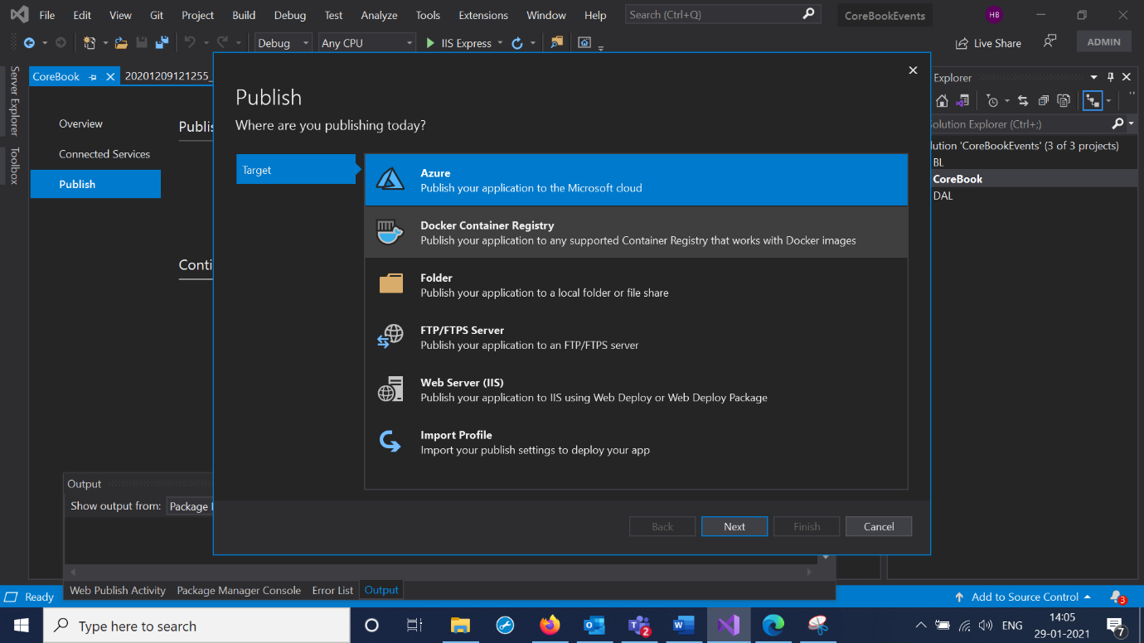

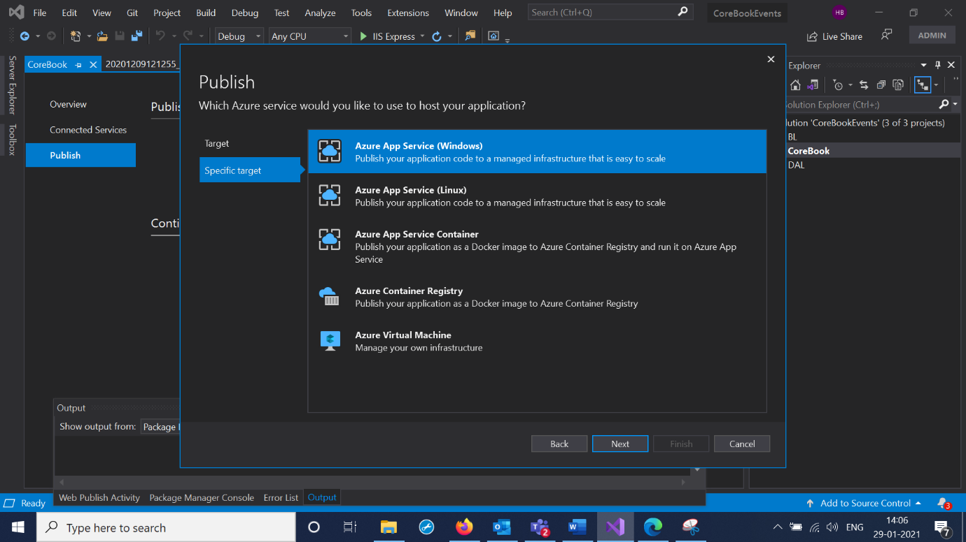

2.Add App Service Instance and Use the resource group from azure portal and select the hosting plan for the Deployment.

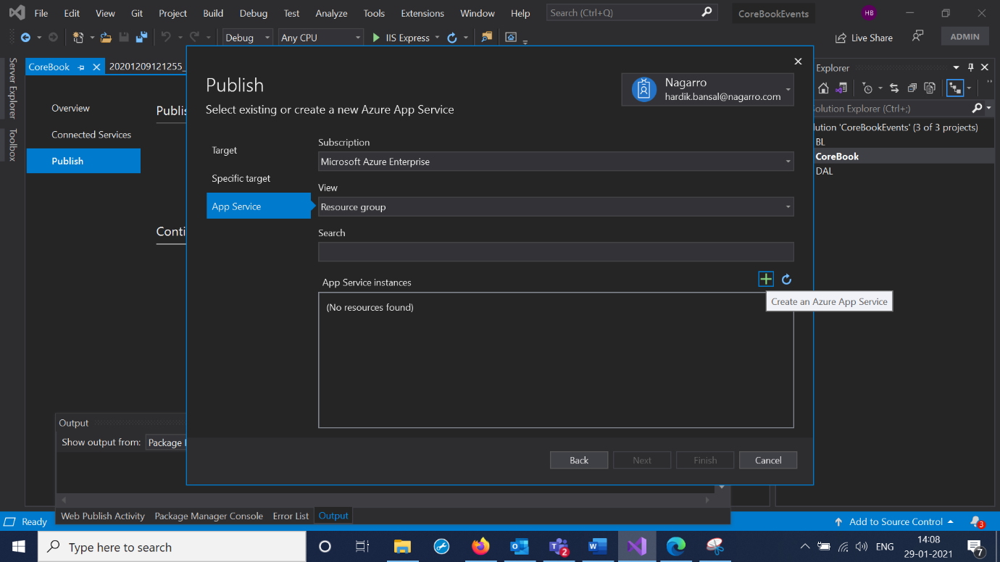

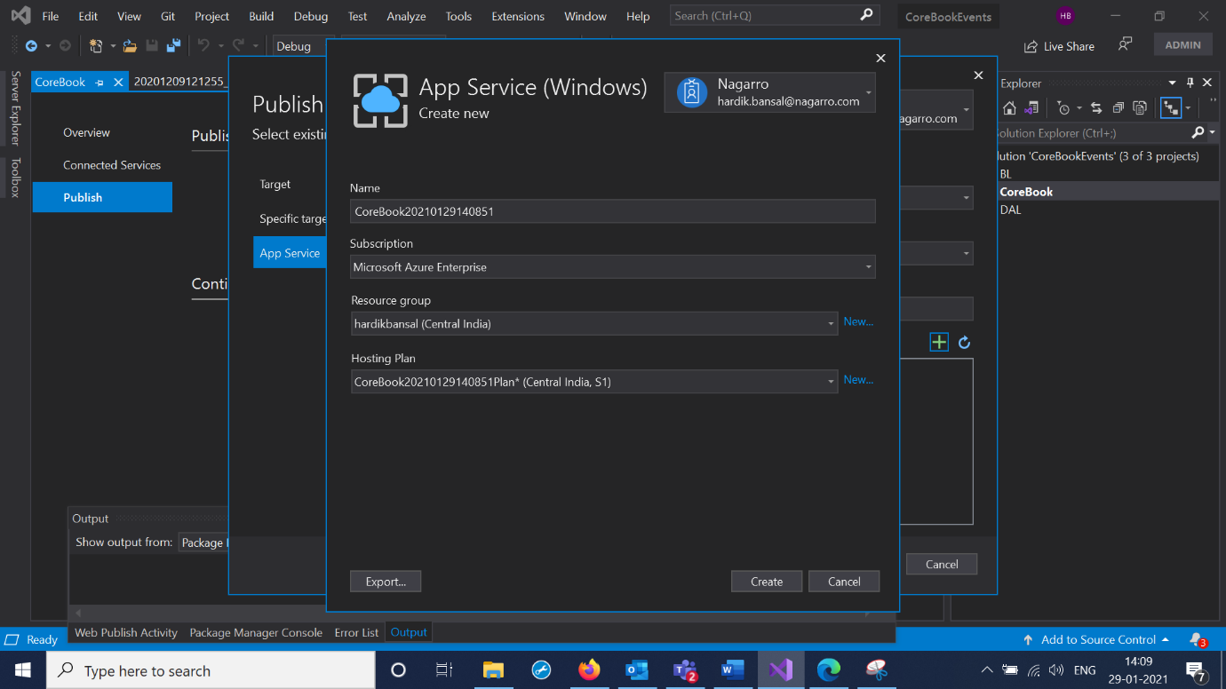

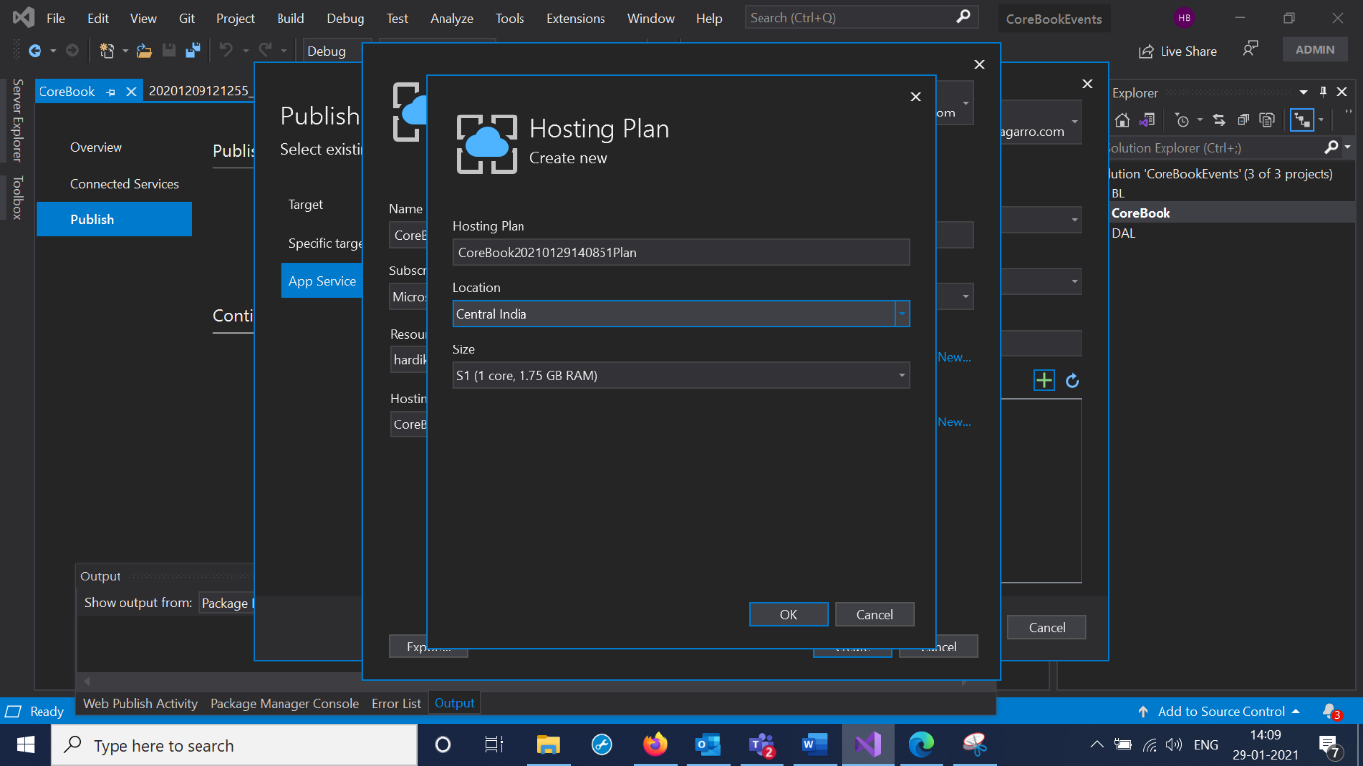

3.Select The App Service and Hit Finish.

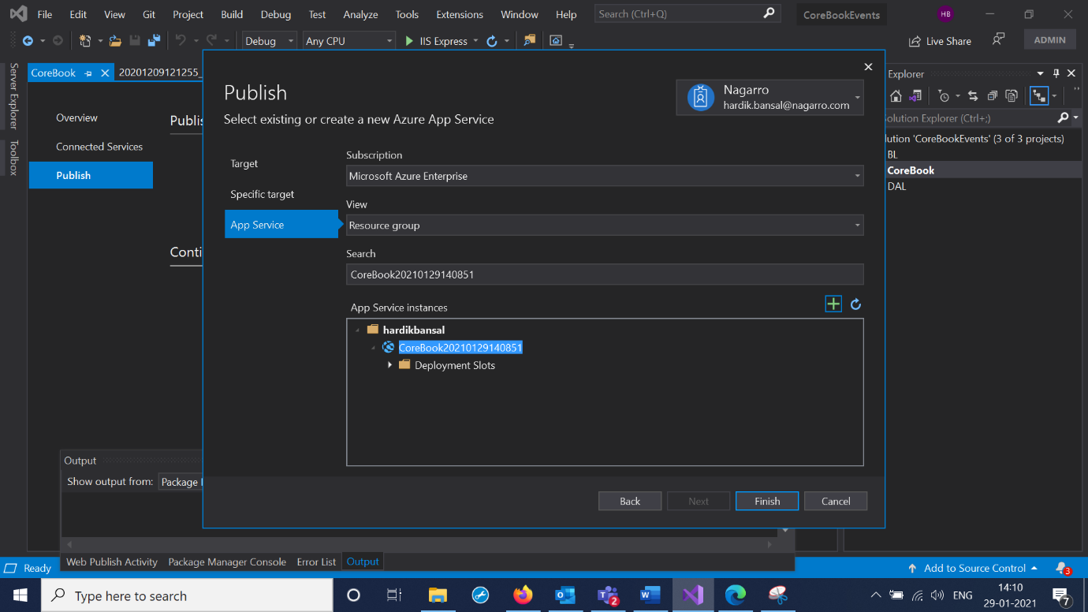

4.Configure the Database and Select Azure SQL Database.

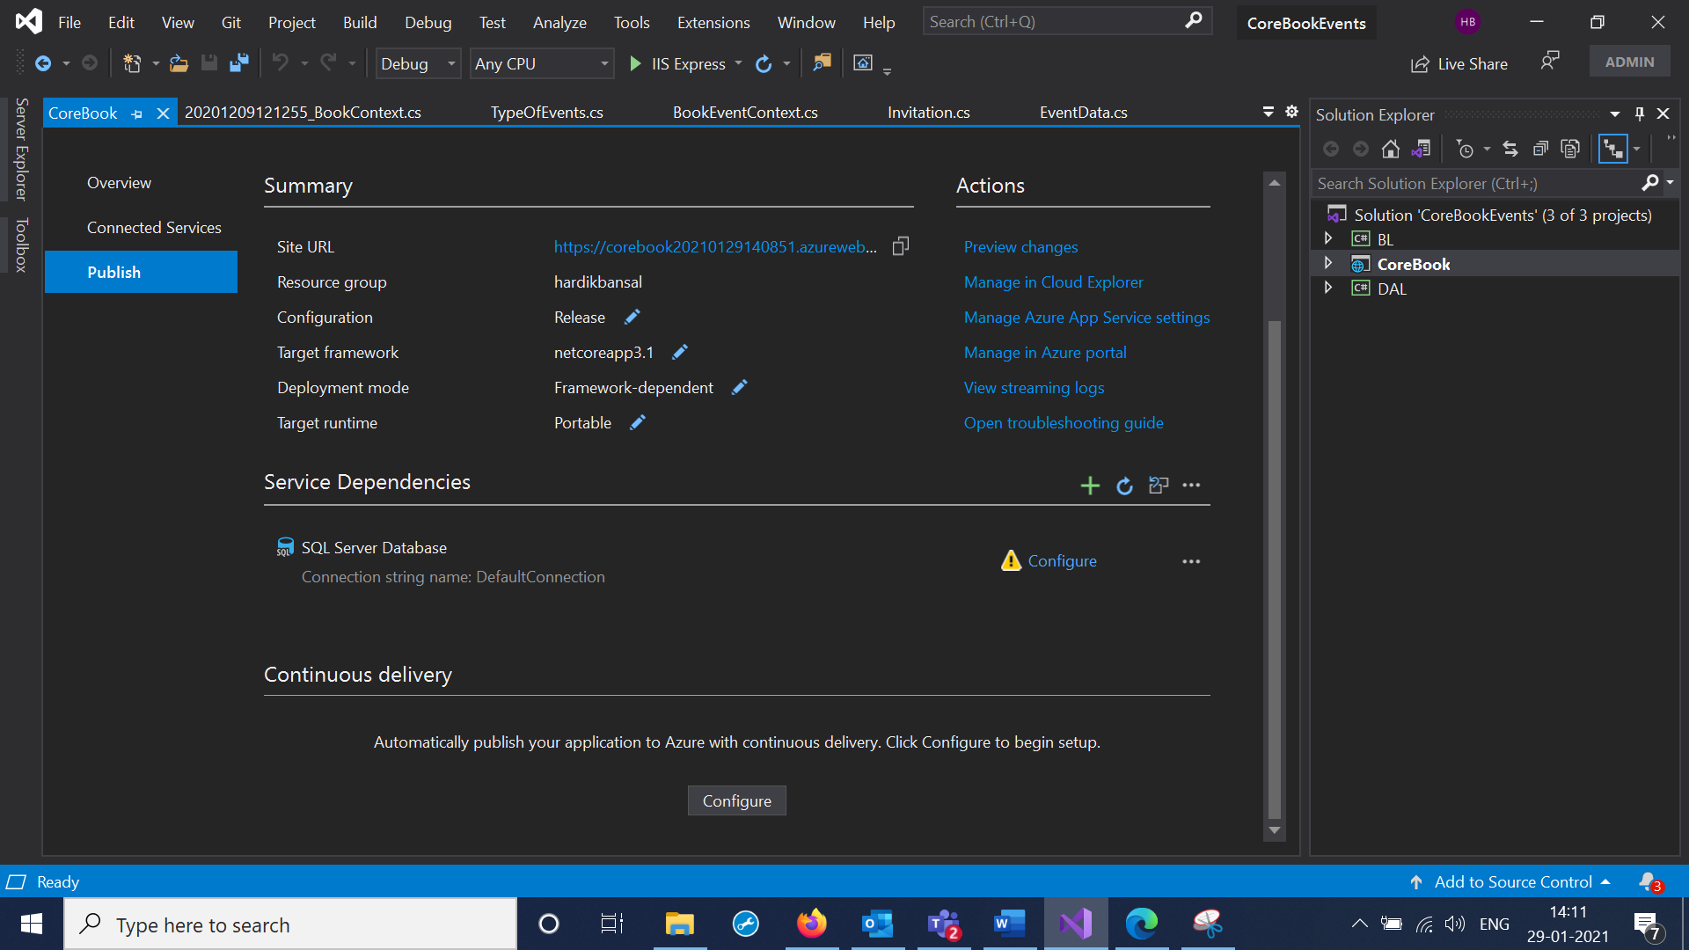

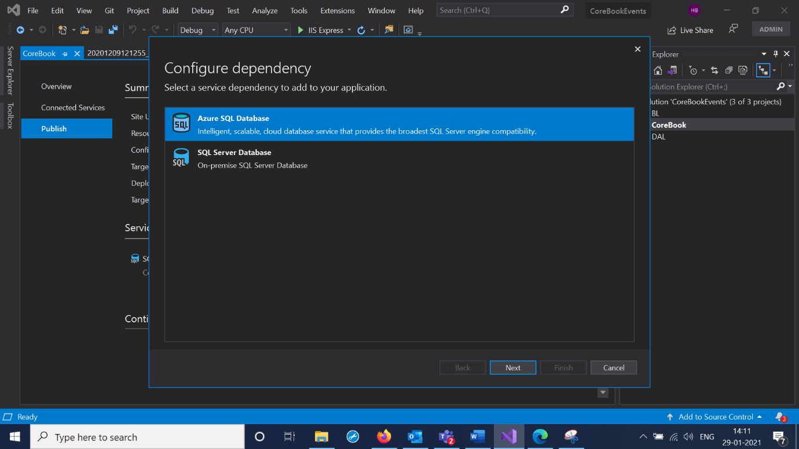

5.Add SQL database Instance ,Add database server and create credentials for the sql servers. Then Press Create.

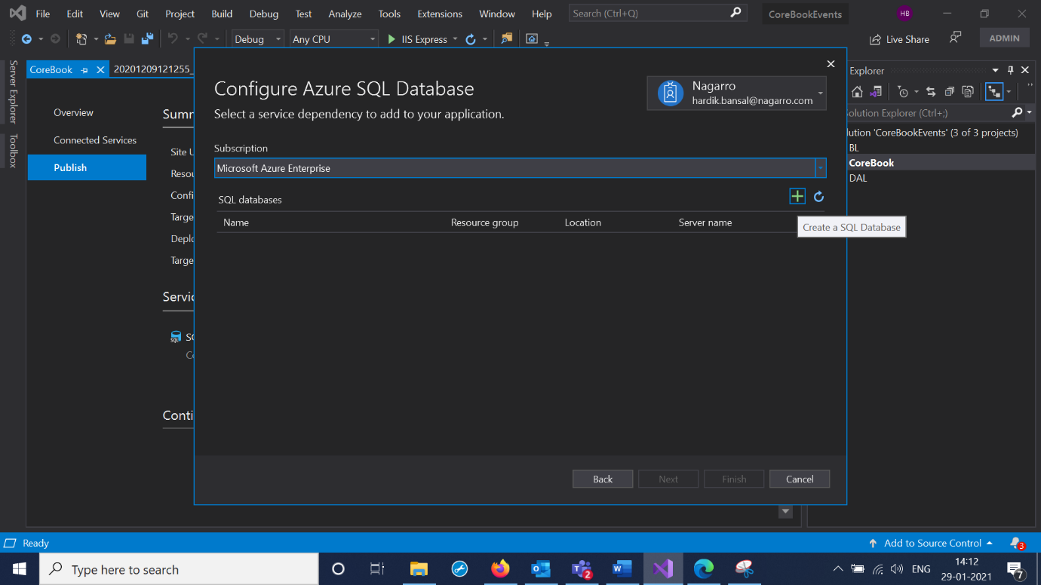

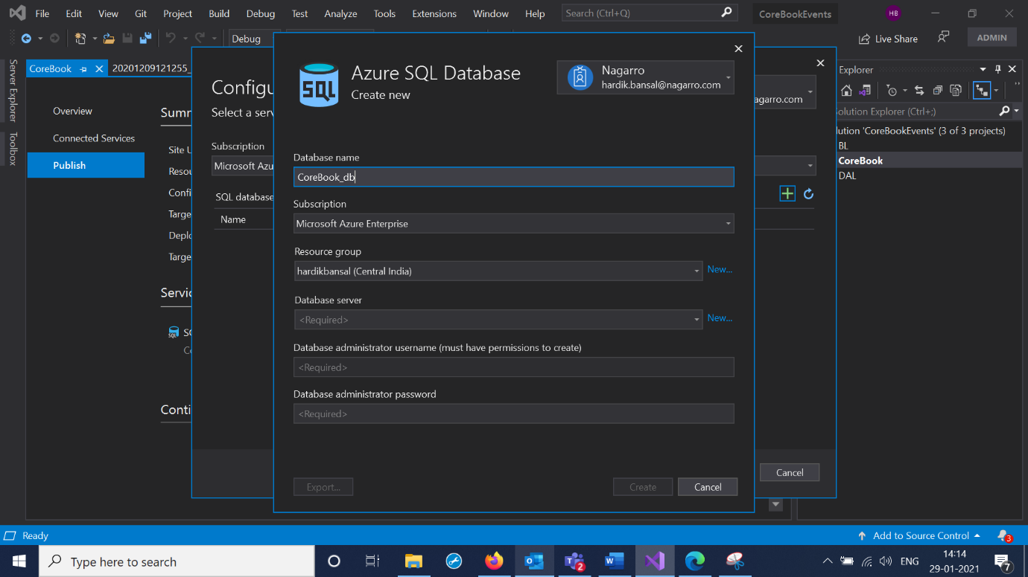

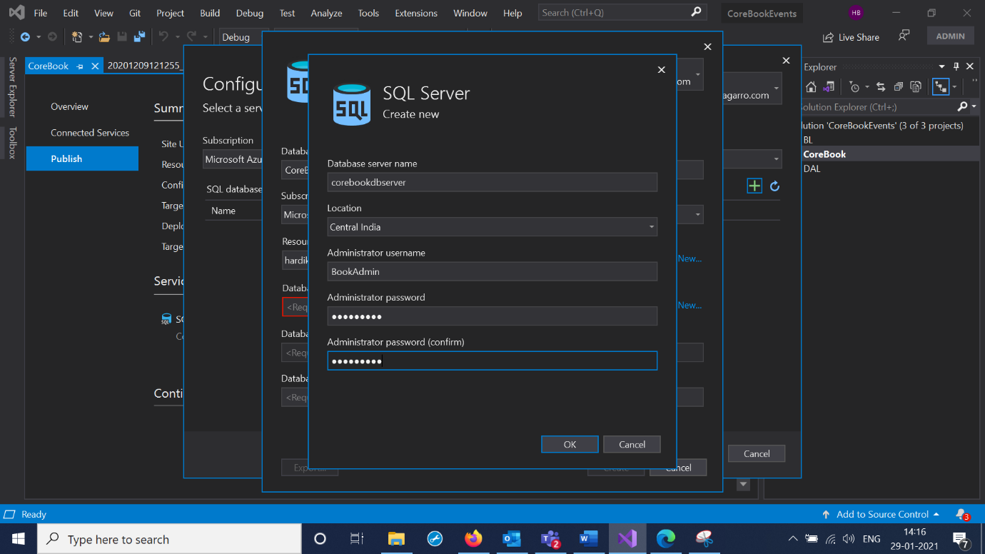

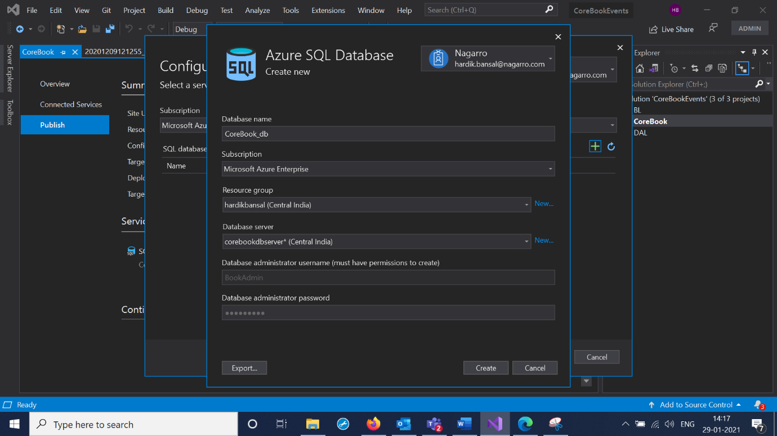

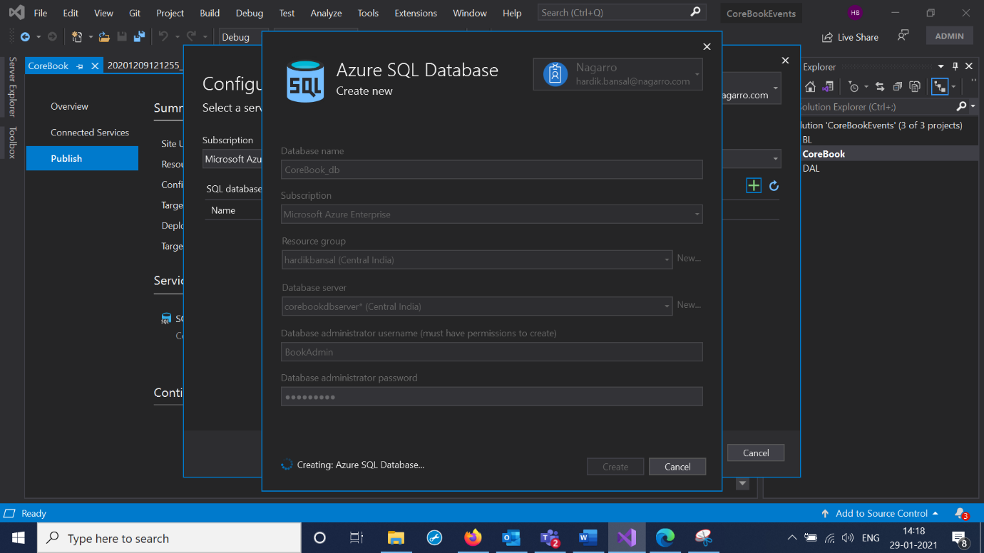

6.Now Hit Finish and database is configured.Select Next

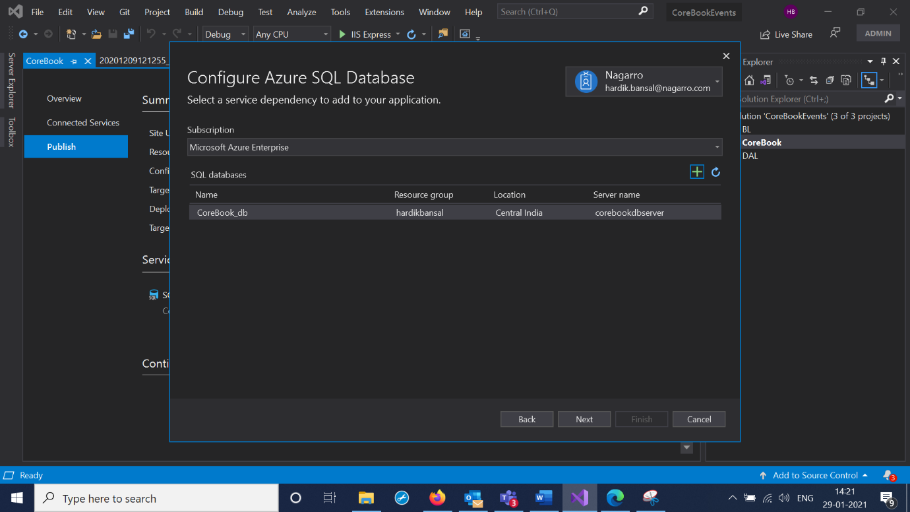

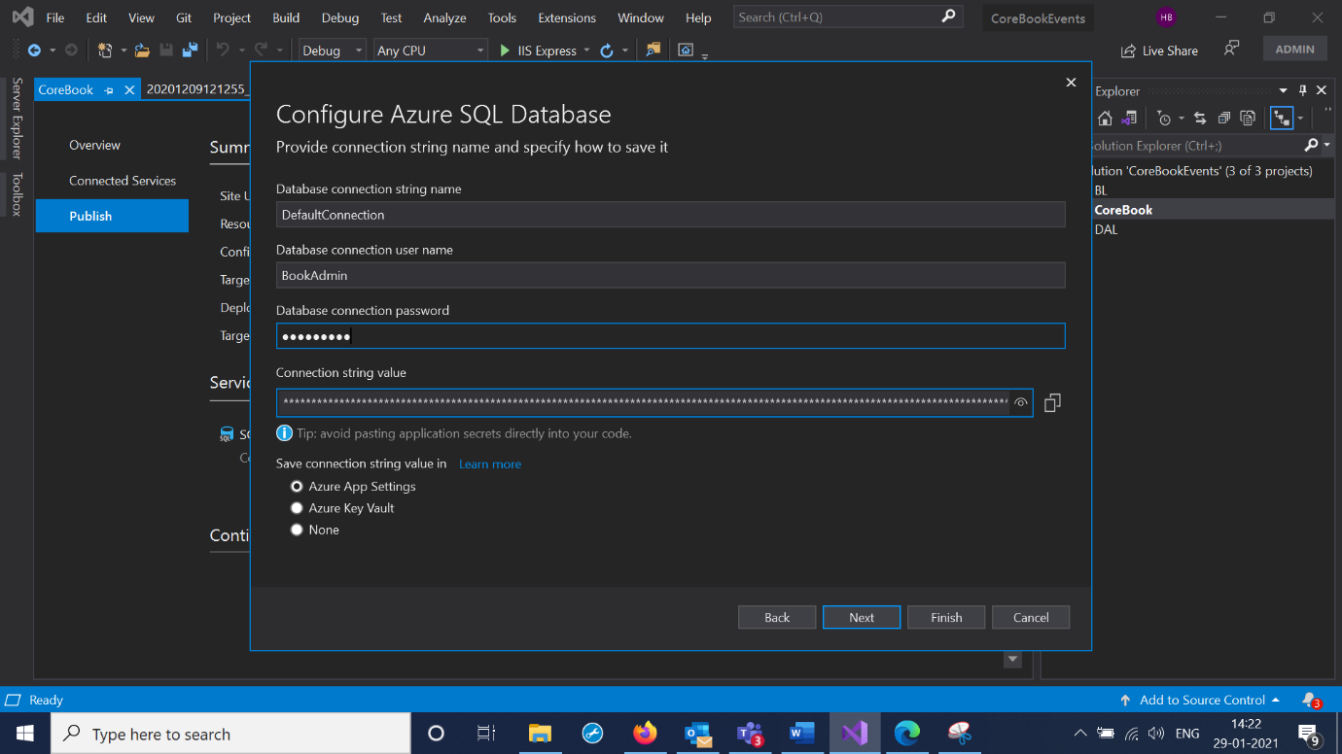

7.Select Edit and Select Settings Tab ,Checked the Database and Entity connection String.

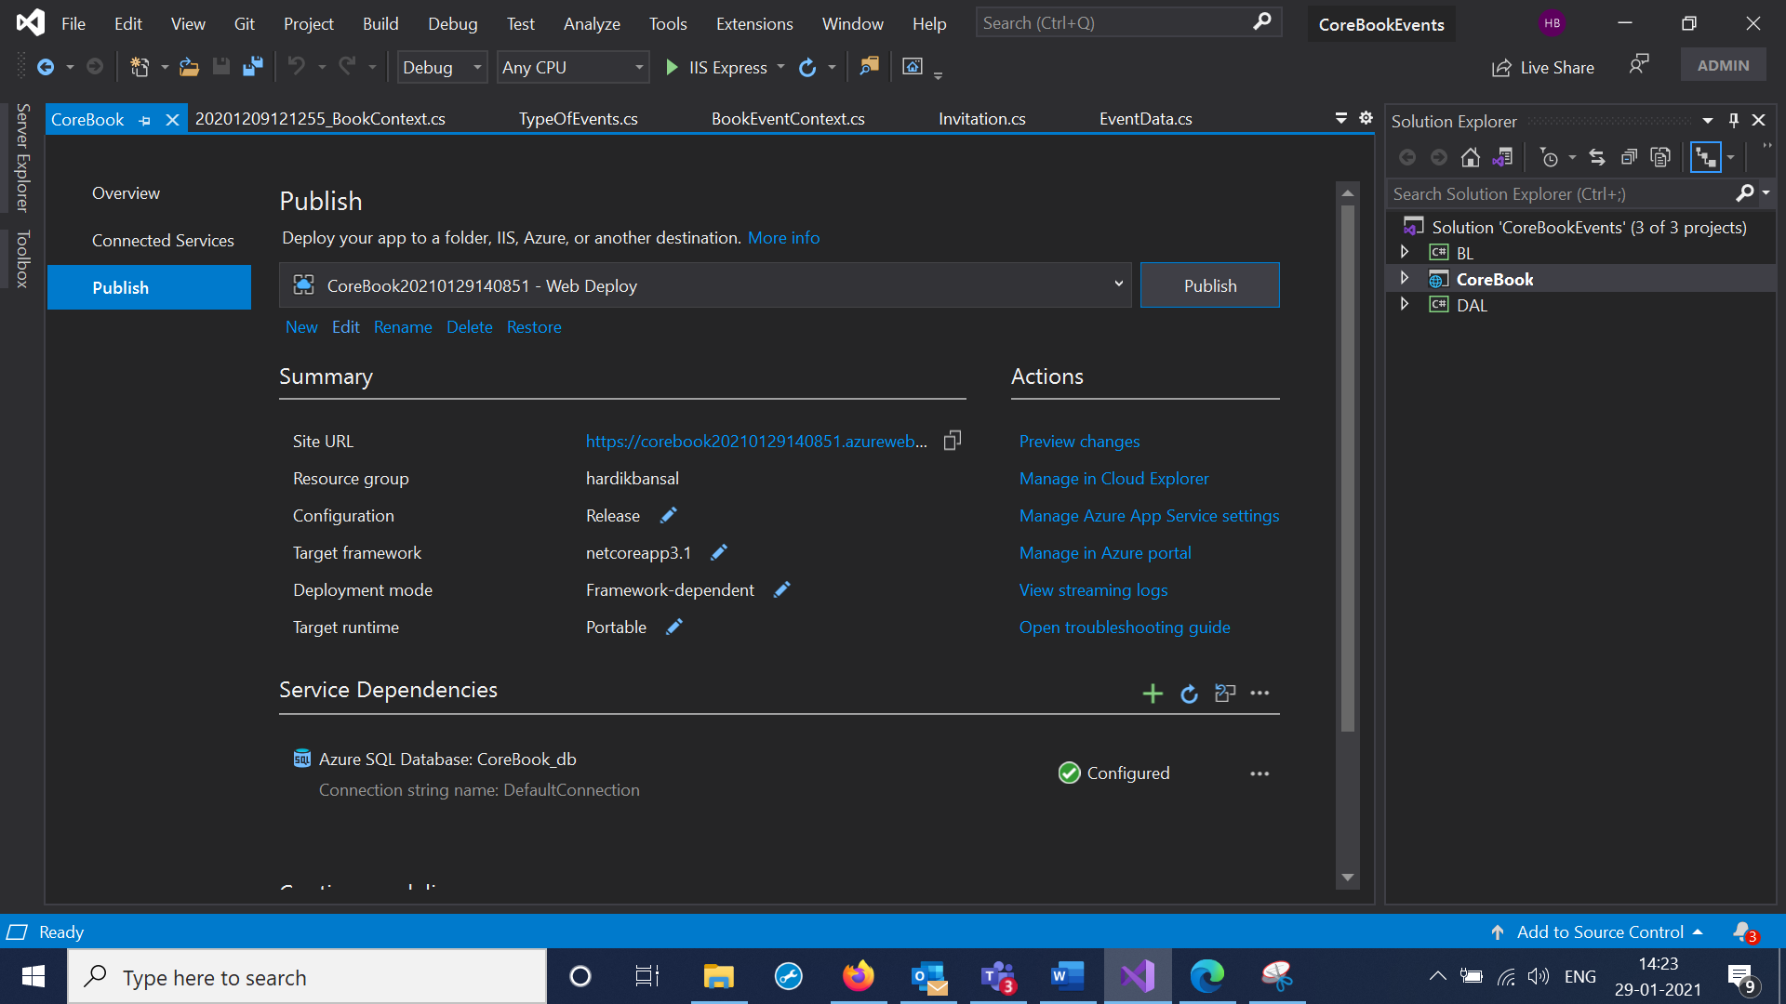

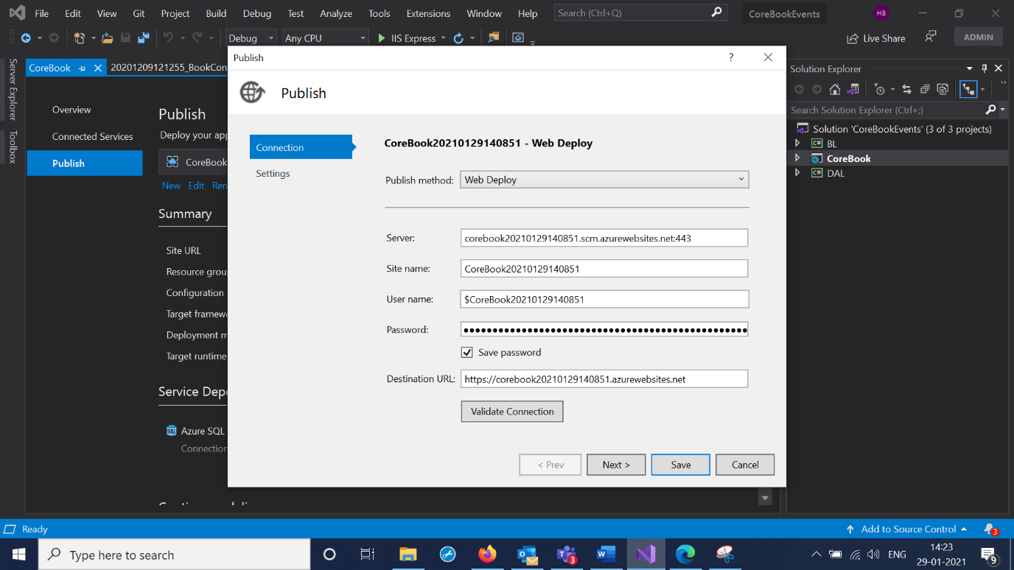

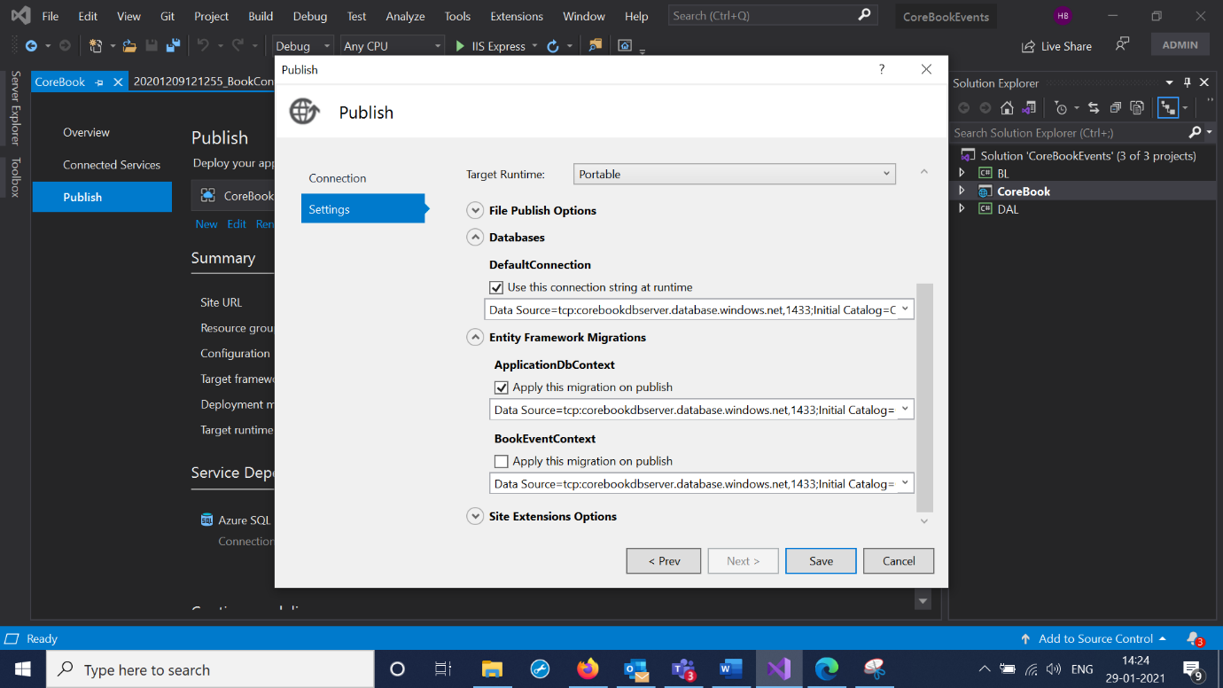

8.Hit Publish and MVC azure url is created .

